

West Coast Collaborative
Test 1 2016
Calculator Free Section

Name: _______________________ Score: _____ / 31

Section 1 is worth 50% of your final test mark.
No calculators or notes are to be used.
Access to approved Sample Mathematics Specialist formulae sheet is permitted. Time limit = 30 minutes.

1. (4 marks)
Given that z is a complex number solve , giving the solution(s) exactly in the form a + bi.

2. [3 marks]

Rewrite as a Cartesian equation.

3. [ 2,4,2 marks ]

The polynomials p(x) and Q(x) are defined as follows:

P(x) = , Q(x)=

a) Show that x-1 and x+1 are factors of P(x)

b) Determine a and b if Q(x) leaves a remainder of 37 when it is divided by , and a remainder of -19 when divided by

c) With these values a and b, determine the remainder when the polynomial 4P(x) + 5Q(x) is divided by

4. [ 3,3 marks]

a) Given $z=a-3i$ and $z+c\overline{z}=12+6i$, determine $a$ and $c$.

b) Given $w=bcis\frac{5π}{6}$ and $\left|{\left(\overline{w}\right)}^{3}\right|=0.001$, determine $b$

and give the principal argument of $w^{3}$.

5. [5 marks]

Use De Moivre's Theorem to find all the roots of z⁴ = -8 + 8√3i. Give your answers exactly in polar form, with r >0 and .

6. [ 5 marks ]

Find all the values, real and complex, of x for which G(x) = 0,

If G(x) = 5x³-15x²+5x-15

END OF SECTION 1


West Coast Collaborative
Test 1 2016
Calculator Section

Name: _______________________ Score: _____ / 29

Section 1 is worth 50% of your final test mark.
Calculators allowed and 1 page of A4 notes, writing on both sides.
Access to approved Sample Mathematics Specialist formulae sheet is permitted. Time limit = 30 minutes.

7. [2, 2, 2, 2 marks]

Suppose that z is a complex number with modulus r and argument θ.
Express in terms of r and θ the modulus and argument of each of the
four complex numbers z₁, z₂, z₃, and z₄ where

( i ) z₁ = z²

( ii ) z₂ = 2z

( iii ) z₃ = z⁻¹

( iv ) z₄ = -iz

8. [ 2,2,2 marks]

The complex numbers of z and w are such that:

z = 3cis( ) and w = cis( )
Determine the following.

a) z + w (in a + bi form) b) w z (in cis form)

c) $\frac{1}{\overline{z}}$ (in cis form and a + bi form)

9. [ 5,5 marks ]

a) On the Argand Diagram below, sketch and label both of the sets of points specified:

i) ii)

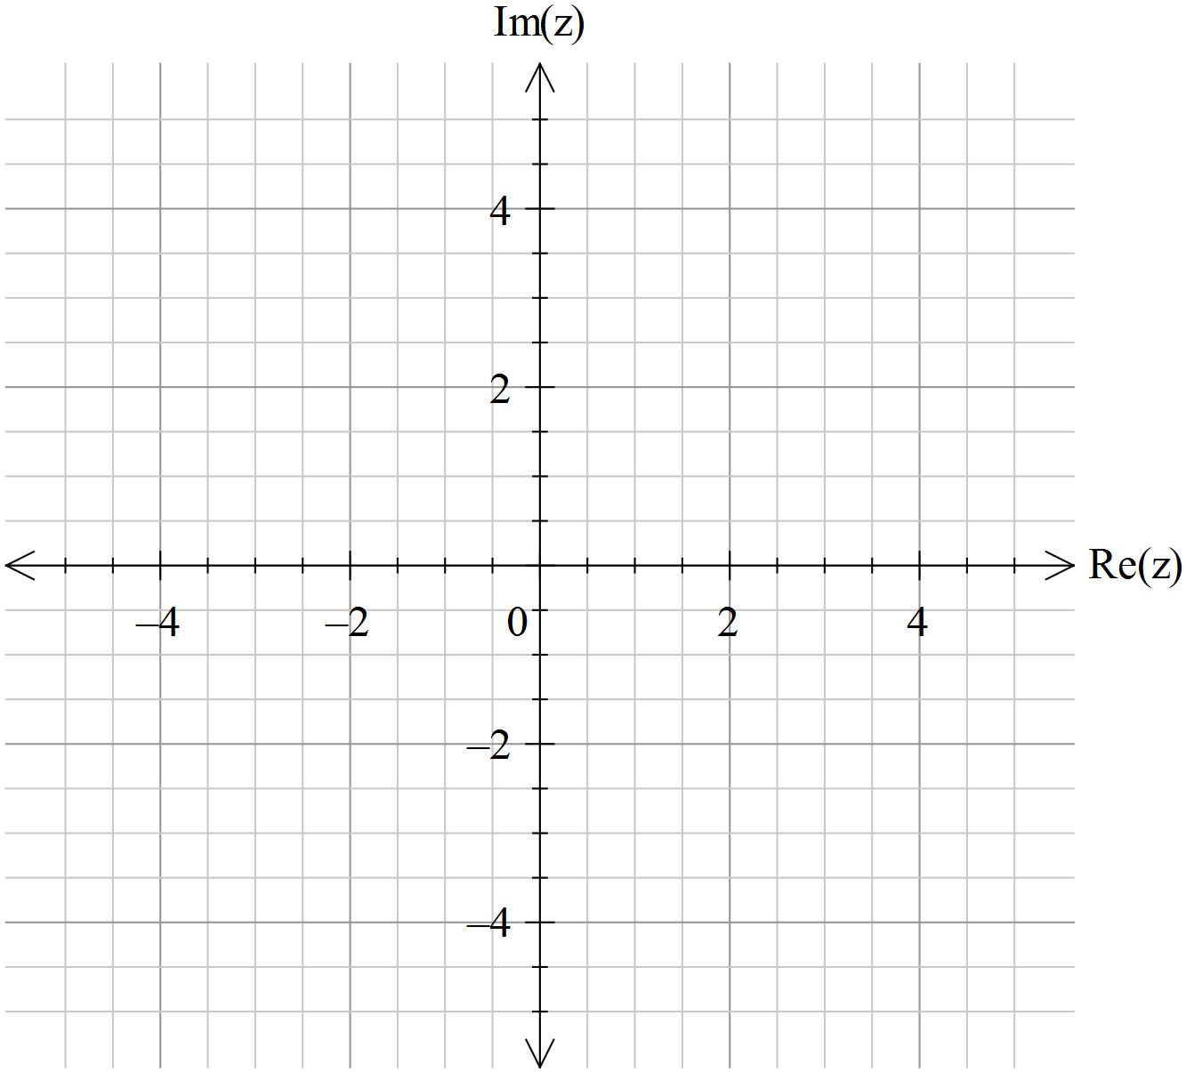

b) Determine to four decimal places the largest possible argument, , of the complex number that satisfies

10. [ 4, 1 marks]
a) Use de Moivre’s theorem to show that $\cos{4x}=\cos^{4}{x}+\sin^{4}{x}-6\cos^{2}{x}\sin^{2}{x}$

b) Use this result to show that $\cos{4x}=1-8\cos^{2}{x}\sin^{2}{x}$

END OF SECTION 2

